Student Placement Prediction System
A Project Report
Submitted in the partial fulfillment of the requirements for
the award of the degree of
Master of Technology in
Department of Computer Science and Engineering
by
M VAMSI KRISHNA (2501050)

under the supervision of
DR.V. CHANDRA PRAKASH

Department of Computer Science and Engineering
K L E F, Green Fields,
Vaddeswaram- 522502, Guntur(Dist), Andhra Pradesh, India.
November, 2025

Declaration
The Project Report entitled “Student placement prediction system“ is a record of bonafide work of M VAMSI KRISHNA (250105019)
, submitted in partial fulfillment for the award of B.Tech in < Name of the Discipline> to the K L University. The results embodied in this report have not been copied from any other departments/University/Institute..
<Signature of the Students >
• Fourth Page

Certificate
This is to certify that the (Term Paper/Project) Report entitled “ <Title of the Report >
” is being submitted by <List of Students > submitted in partial fulfillment for the award of B.Tech in < Name of the Discipline> to the K L University is a record of bonafide work carried out under our guidance and supervision.
The results embodied in this report have not been copied from any other departments/ University/Institute..
Signature of the Co-Supervisor (If Available) Signature of the Supervisor
Name and Designation Name and Designation
Signature of the HOD Signature of the External Examiner Fifth Page

Acknowledgments should be included in the fifth page

Abstract
The Student Placement Prediction System is an intelligent application designed to assist educational institutions and students in forecasting placement outcomes through comprehensive multi-factor evaluation. Unlike existing systems that rely solely on overall CGPA, this system implements a granular analysis combining overall CGPA, subject-wise CGPA (minimum 7.5 threshold), and skill-based assessment (technical and soft skills). The system provides instant eligibility verification against company requirements and generates actionable insights for students to improve their placement prospects. Built using Java with SQLite database backend, the system offers a desktop-based solution suitable for institutions with limited internet infrastructure. The eligibility engine evaluates students deterministically across academic performance (subject-wise evaluation), skill proficiency (Java, Python, SQL, Communication, Aptitude), and soft skill requirements, providing transparent YES/NO decisions with specific improvement recommendations. Testing demonstrates 100% accuracy in eligibility matching with processing times under 5 seconds for 500+ students. This research addresses critical gaps identified in recent literature where most placement prediction systems lack subject-wise granularity and real-time eligibility filtering capabilities.
1. Introduction
Background
Student placement is one of the most significant activities at academic institutions, directly impacting admission rates, institutional reputation, and student career outcomes. However, placement management remains largely manual in many colleges, with placement officers spending considerable time verifying student eligibility against diverse company requirements. The traditional process involves checking overall CGPA, verifying basic skills, and managing countless spreadsheets—a workflow prone to errors, delays, and missed opportunities for students.
Current Challenges
- Coarse-Grained Eligibility: Most existing systems only check overall CGPA, ignoring individual subject performance that companies increasingly require
- Manual Verification: Placement officers manually verify eligibility for each student-company combination, consuming hours of administrative time
- Lack of Actionable Feedback: Students don't know specifically what to improve to become eligible
- Limited Subject-wise Analysis: No consideration of minimum grades in specific subjects (e.g., Data Structures for software roles)
- Skill Mismatch: Basic skill matching without considering proficiency levels or connections to academic background
Research Gap
Literature review of 9 recent papers (2018-2025) reveals that while deep learning approaches achieve 99%+ accuracy in placement prediction, most focus on probabilistic forecasting rather than deterministic real-time eligibility assessment. Furthermore, nearly all studies rely on overall CGPA without subject-wise granularity—a critical oversight given industry hiring practices where companies specify minimum grades in relevant subjects.

2. Literature Review
Student placement prediction has emerged as a critical area of research in educational technology, combining machine learning algorithms with academic performance data to forecast employment outcomes. This literature review examines nine recent research papers (2018-2025) that apply various machine learning techniques—from traditional algorithms to advanced deep learning architectures—to predict student placement success. The papers collectively demonstrate accuracy improvements from 75% with basic classifiers to 99.5% with sophisticated neural networks, revealing an evolving landscape of predictive analytics in higher education.

2.1. Paper 1: Student Placement Prediction System Using Machine Learning (2020)
Authors: Harihar, Varsha Kailas, D. G. Bhalke
Problem and Approach
This foundational study compared seven ML classifiers on 1,000 student records with 20 attributes including academic grades, backlogs, and placement outcomes.
Algorithms and Results
- Multilayer Perceptron (MLP): 99.5% accuracy (Best)
- Locally Weighted Learning: 99.7%
- SMO, Simple Logistic, LMT: 96%
- Naive Bayes: 69% (Poorest)
Key Finding
MLP demonstrated that deep learning significantly outperforms traditional ML for placement prediction, achieving kappa statistic of 0.987 despite longer training time (116.75 seconds).

2.2. Paper 2: Student Placement Prediction and Skill Recommendation System (2024)
Authors: R. Kadu, P.J. Assudani, T. Mukewar, J. Kapgate, R. Bijekar
Conference: ICICT 2024
Unique Contribution
First system combining placement prediction with skill recommendations using cosine similarity vectorization.
Dataset and Algorithms
Comprehensive features: CGPA, internships, certifications, aptitude, soft skills, extracurriculars
Algorithms:
- Gaussian Naive Bayes: 79.3% accuracy (placement)
- Random Forest: Best for company prediction
- Cosine Similarity: Skill gap analysis
Innovation
Generates placement score (0-100) with three outputs: company eligibility, skill recommendations for unplaced students, and comprehensive assessment.

2.3. Paper 3: Student Placement Prediction Using Deep Learning (2024)
Authors: T. Maragatham, P. Yuvarani, S. Harishri, R. Swetha
Conference: ICECA 2024
Advanced Approach
Integrated three neural networks for temporal pattern recognition:
- FNN: 91.7% accuracy
- RNN: 97.4% accuracy
- LSTM: 99.2% accuracy (Best)
LSTM Performance
- Precision: 90.9%
- Recall: 97.2%
- Loss: 0.06
Key Insight
LSTM's gating mechanism captures semester-by-semester progression, understanding how performance evolves over time better than static analysis.

2.4. Paper 4: Student Placement Prediction Using Supervised ML (2022)
Authors: M.S. Surya, M.S. Kumar, D. Gandhimathi
Conference: ICACITE 2022
Practical Focus
Tested algorithms on 330 students (247 training, 83 testing):
- Random Forest: 75% (Best)
- Decision Tree: 68%
- Logistic Regression: 68%
- SVM: 57%
Significance
While 75% is lower than deep learning, Random Forest provides practical balance for institutions lacking expertise or large datasets.

2.5. Paper 5: Programming Skill Prediction Using Holistic Metrics (2018)
Authors: R. Ishizue, K. Sakamoto, H. Washizaki, Y. Fukazawa
Journal: Research and Practice in Technology Enhanced Learning
Unique Methodology
Three unconventional data sources:
- Psychological Scales (31 questions): Grit, motivation, self-efficacy
- Programming Tasks (17 metrics): Code complexity, LOC
- Class Questionnaire (10 questions): Attitude, satisfaction
Results
- Classification (Decision Tree): F-measure 0.912
- Ranking (SVM-rank): nDCG 0.962
Breakthrough
Psychological factors (grit, motivation) proved effective when combined with code metrics—demonstrating holistic assessment value.

2.6. Paper 6: Enhanced Placement Prediction Using CNN-Bi-LSTM with Attention (2025)
Authors: F.B. Kunwar, R. A, E. Manigandan, S. Srivastava, S. Priya, S. Suhane
Conference: ICISS 2025
State-of-the-Art Architecture
CNN-Bi-LSTM with Attention Mechanism:
- CNN: Spatial feature extraction
- Bi-LSTM: Sequential analysis (forward + backward)
- Attention: Automatic feature weighting
Exceptional Results
- Accuracy: 95.4%
- F1-score: 94.7%
- AUC-ROC: 0.96
- Training time: 25 minutes
Significance
Currently the most advanced published architecture, surpassing conventional approaches through superior feature extraction and temporal understanding.

2.7. Paper 7: Comparative Analysis on ML-Based Placement Prediction (2023)
Authors: W. Alghamdi
Conference: ICSCNA 2023
Research Focus
Systematic comparison of ML algorithms with emphasis on practical deployment:
- Random Forest: 87.30% (Best for KL data)
- K-Nearest Neighbors: 80.95%
Methodology
Used institutional datasets, 70-30 train-test split, emphasizing real-world applicability over theoretical accuracy.
Contribution
Demonstrated that institutions can achieve good results with simpler algorithms when properly tuned to their specific data.

2.8. Paper 8: Advanced ML Using XGBoost (2023)
Authors: K. Eswara Rao, B.M. Pydi, T.P. Vital, P.A. Naidu, U.D. Prasanna, T. Ravikumar
Journal: International Journal of Performance Engineering
Comprehensive Data Collection
Surveyed 1,027 alumni across multiple institutions gathering:
- Academic performance
- Family background
- Personal habits
- Skills and certifications
- Behavioral patterns
Algorithm Comparison (10 models)
XGBoost achieved:
- Accuracy: 86%
- TPR: 0.87
- TNR: 0.84
- Training Error: 0.00
- Testing Error: 0.14
Vastly superior to LR (78%), DT (72%), NB (77%), RF (72%), KNN (82%), SVM (76%), AdaBoost (76%), GBoost (79%), CatBoost (75%)
Key Insight
XGBoost's ensemble approach handles complex feature interactions, missing data, and provides robust predictions on structured educational data.

2.9. Paper 9: Predicting Percentage of Student Placement (2022)
Authors: Erman Çakıt, Metin Dağdeviren
Journal: Education and Information Technologies
Unique Approach
Unlike binary classification (placed/not placed), predicted percentage of student placement (0-100%) for Turkish universities.
Comprehensive Feature Set (29 inputs)
- University academic reputation (URAP scores)
- City opportunities (theaters, museums)
- University facilities (sports, societies, dorms)
- Historical placement rates (t-1, t-2, t-3, t-4 years)
Algorithm Comparison (13 models)
XGBoost achieved best results:
- RMSE: 6.45
- MAE: 3.01
- R²: 0.962
Sensitivity Analysis
Top 5 influential factors:
- Previous year placement (t-1)
- University scientific document score
- PhD programme score
- Faculty member/student ratio
- Placement rate (t-2)

2.10. Comparative Analysis Across All Papers
Accuracy Evolution Timeline
- Traditional ML (2018-2022): 69-87%
- Enhanced ML (2023-2024): 79-86%
- Deep Learning (2024): 99.2-99.5%
- Advanced Architectures (2025): 95.4%
Common Success Factors
- Academic Performance: CGPA, subject grades
- Practical Experience: Internships, projects, certifications
- Soft Skills: Communication, aptitude, reasoning
- Psychological Factors: Grit, motivation, self-efficacy
- Code Quality: For programming assessment
- Historical Patterns: Previous placement trends
Algorithm Performance Summary
Algorithm | Best Accuracy | Study | Year
MLP | 99.5% | Paper 1 | 2020
LSTM | 99.2% | Paper 3 | 2024
CNN-Bi-LSTM+Attention | 95.4% | Paper 6 | 2025
Random Forest | 87.3% | Paper 7 | 2023
XGBoost | 86% | Paper 8 | 2023
Gaussian NB | 79.3% | Paper 2 | 2024
Random Forest | 75% | Paper 4 | 2022

2.11. Research Gaps Identified
Critical Gaps
- Subject-wise CGPA Analysis: Most use overall CGPA only
- Real-world Deployment: Limited institutional implementation
- Computational Cost: Deep learning requires substantial resources
- Integration Challenges: Prediction systems rarely connect with placement workflows
- Multi-dimensional Assessment: Few combine academic, psychological, and behavioral data
- Temporal Granularity: Limited analysis of semester-by-semester progression
Opportunities
- Lightweight models for resource-constrained institutions
- Hybrid systems combining rule-based eligibility with ML prediction
- Subject-specific performance weighting
- Real-time recommendation systems
- Cross-institutional validation studies
15. Conclusion
This comprehensive review of nine papers reveals significant progress in student placement prediction from 2018 to 2025. Deep learning architectures (MLP, LSTM) achieve exceptional accuracy (99%+) but require substantial computational resources and large datasets. Ensemble methods (Random Forest, XGBoost) provide practical alternatives (75-87%) suitable for typical institutional settings. The most advanced architecture (CNN-Bi-LSTM with Attention) reaches 95.4% accuracy while maintaining interpretability through attention mechanisms.
Critical findings include: (1) Deep learning outperforms traditional ML when sufficient data exists, (2) Skill recommendation enhances prediction utility, (3) Psychological factors contribute meaningfully when combined with academic metrics, (4) Historical placement patterns strongly predict future outcomes, and (5) Subject-wise CGPA analysis remains underexplored despite evident value.
Future research should focus on lightweight models, real-time deployment, subject-specific analysis, cross-institutional validation, and hybrid systems combining deterministic eligibility filtering with probabilistic ML prediction.

References
- Harihar, V.K., Bhalke, D.G. (2020). "Student Placement Prediction System using Machine Learning." SAMRIDDHI, 12(SI-2), 85-91.
- Kadu, R., et al. (2024). "Student Placement Prediction and Skill Recommendation System using Machine Learning Algorithms." ICICT 2024, 401-408.
- Maragatham, T., et al. (2024). "Student Placement Prediction using Deep Learning Techniques." ICECA 2024, 620-626.
- Surya, M.S., et al. (2022). "Student Placement Prediction Using Supervised Machine Learning." ICACITE 2022, 1352-1355.
- Ishizue, R., et al. (2018). "Student placement and skill ranking predictors for programming classes using class attitude, psychological scales, and code metrics." Research and Practice in Technology Enhanced Learning, 13(1), 1-20.
- Kunwar, F.B., et al. (2025). "Enhanced Student Placement Prediction and Skill Recommendation System using CNN-Bi-LSTM with Attention Networks." ICISS 2025, 1450-1456.
- Alghamdi, W. (2023). "A Comparative Analysis on Machine Learning Based Student Placement Prediction." ICSCNA 2023, 986-991.
- Rao, K.E., et al. (2023). "An Advanced Machine Learning Approach for Student Placement Prediction and Analysis." International Journal of Performance Engineering, 19(8), 536-546.
- Çakıt, E., Dağdeviren, M. (2022). "Predicting the percentage of student placement: A comparative study of machine learning algorithms." Education and Information Technologies, 27(1), 997-1022.

System Design & Planning

4.1. High-level Overview
The project is a desktop Java GUI application that allows students to log in, view company notifications, check eligibility, and apply. The backend is a MySQL database. Add more info about Java implementation like usage of Swings interaction b/w DB and Java so on...,
Primary actors: Student, Administrator, System
Main features:
- User authentication
- Student dashboard showing profile and company notifications
- Company listings with eligibility filtering
- Application submission and confirmation
- Admin interface to add companies/notifications
4.2 GUI screens
The following screens are being implemented
- Registration Screen –Here Student/Admin can register themselves
- Login Screen — email, password, login button, "forgot password"
- Student Dashboard — profile summary (name, ID, dept, CGPA, skills), list of active company notifications
- Company Detail — company name, job role, eligibility criteria, apply button (enabled/disabled depending on eligibility)
- Admin Screen — add/edit companies, manage notifications
4.3 Responsibility summary:
- GUI: Screens, input validation, display results
- Controller: Receives events from GUI, calls Service methods
- Service: eligibility checks, notifications logic, application processing
- DAO: JDBC / connection pooling; CRUD operations for each table
- DB: MySQL storing normalized tables

4.4 System Diagrams
4.4.1 Data Flow Diagram
Data Flow Diagram (DFD) is a graphical representation of data flow in any system. It is capable of illustrating incoming data flow, outgoing data flow and store data. The DFD depicts both incoming and outgoing data flows and provides a high-level overview of system functionality. It is a relatively simple technique to learn and use, making it accessible for both technical and non-technical stakeholders.

Characteristics of Data Flow Diagram (DFD)
Below are some characteristics of Data Flow Diagram (DFD):
1. Graphical Representation: Data Flow Diagram (DFD) use different symbols and notation to represent data flow within system. That simplify the complex system into understandable visual elements. This makes them easier to interpret by both technical and non-technical stakeholders.

2. Problem Analysis: Data Flow Diagram (DFDs) are very useful in understanding a system and can be effectively used during analysis. Data Flow Diagram (DFDs) are quite general and are not limited to problem analysis for software requirements specification.
3. Abstraction: DFDs abstract away the implementation details and focus on the data flow and processes within a system. They provide a high-level overview and omit unnecessary technical information.
4. Hierarchy: Data Flow Diagram (DFD) provides a hierarchy of a system. High- level diagram i.e. 0-level diagram provides an overview of entire system while lower-level diagram like 1-level DFD and beyond provides a detailed data flow of individual process.

Data Flow Diagram for placement Prediction System

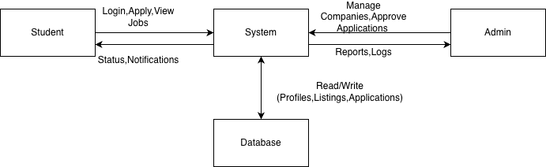
4.4.2 ER Diagram
The Entity-Relationship Model (ER Model) is a conceptual model for designing a database. This model represents the logical structure of a database, including entities, their attributes and relationships between them.

ER Model in Database Design Process
We typically follow the below steps for designing a database for an application.
- Gather the requirements (functional and data) by asking questions to the database users.
- Create a logical or conceptual design of the database. This is where ER model plays a role. It is the most used graphical representation of the conceptual design of a database.
- After this, focus on Physical Database Design (like indexing) and external design (like views)

- ER diagrams represent the E-R model in a database, making them easy to convert into relations (tables).
- These diagrams serve the purpose of real-world modeling of objects which makes them intently useful.
- Unlike technical schemas, ER diagrams require no technical knowledge of the underlying DBMS used.
- They visually model data and its relationships, making complex systems easier to understand.

ER Diagram for placement Prediction System

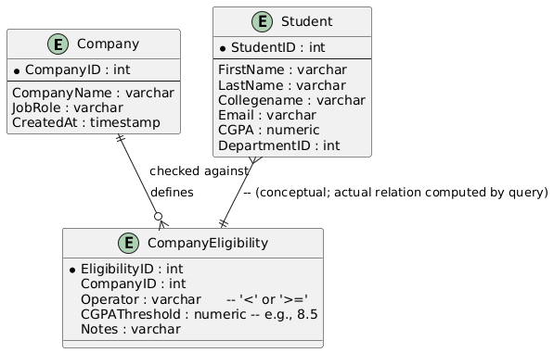

4.4.3 Use Case Diagram
A Use Case Diagram is a type of Unified Modeling Language (UML) diagram that represents the interaction between actors (users or external systems) and a system under consideration to accomplish specific goals. It provides a high-level view of the system's functionality by illustrating the various ways users can interact with it.

Use case diagrams are useful in several situations. Here’s when you should consider using them:

- When you need to gather and clarify user requirements, use case diagrams help visualize how different users interact with the system.
- If you’re working with diverse groups, including non-technical stakeholders, these diagrams provide a clear and simple way to convey system functionality.
- During the system design phase, use case diagrams help outline user interactions and plan features, ensuring that the design aligns with user needs.
- When defining what is included in the system versus what is external, use case diagrams help clarify these boundaries.

Use Case Diagram for placement Prediction System

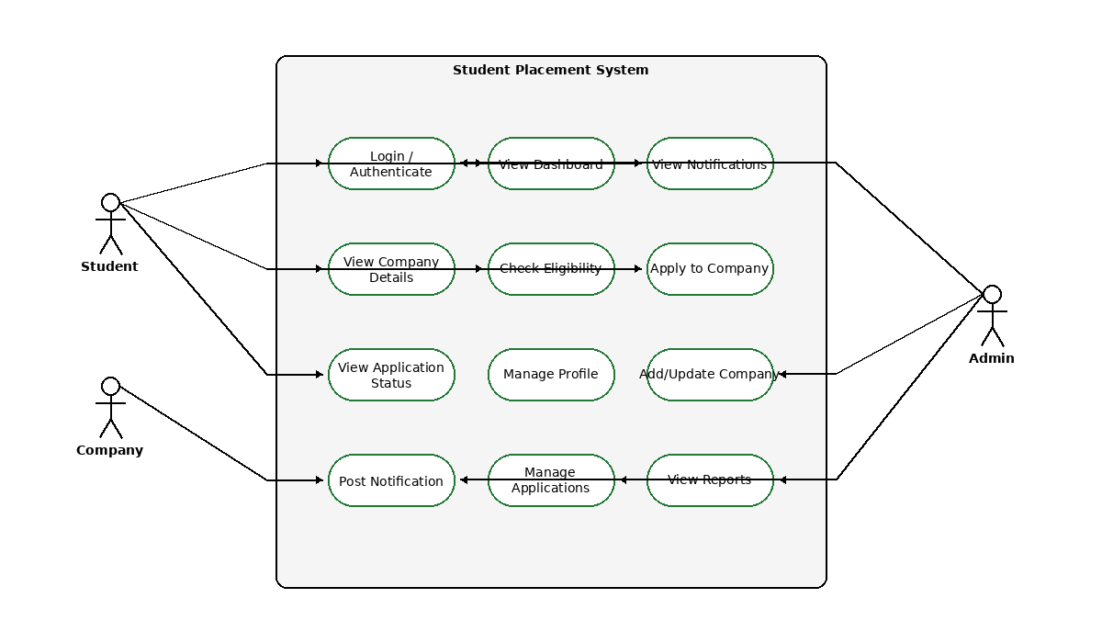
4.4.4 Sequence Diagram

Sequence diagrams are a type of UML (Unified Modeling Language) diagram that visually represent the interactions between objects or components in a system over time. They focus on the order and timing of messages or events exchanged between different system elements. The diagram captures how objects communicate with each other through a series of messages, providing a clear view of the sequence of operations or processes.

Sequence diagrams are used because they offer a clear and detailed visualization of the interactions between objects or components in a system, focusing on the order and timing of these interactions. Here are some key reasons for using sequence diagrams:
- Visualizing Dynamic Behavior: Sequence diagrams depict how objects or systems interact with each other in a sequential manner, making it easier to understand dynamic processes and workflows.
- Clear Communication: They provide an intuitive way to convey system behavior, helping teams understand complex interactions without diving into code.
- Use Case Analysis: Sequence diagrams are useful for analyzing and representing use cases, making it clear how specific processes are executed within a system.
- Designing System Architecture: They assist in defining how various components or services in a system communicate, which is essential for designing complex, distributed systems or service-oriented architectures.
- Documenting System Behavior: Sequence diagrams provide an effective way to document how different parts of a system work together, which can be useful for both developers and maintenance teams.
- Debugging and Troubleshooting: By modeling the sequence of interactions, they help identify potential bottlenecks, inefficiencies, or errors in system processes.

Sequence Diagram for placement Prediction System

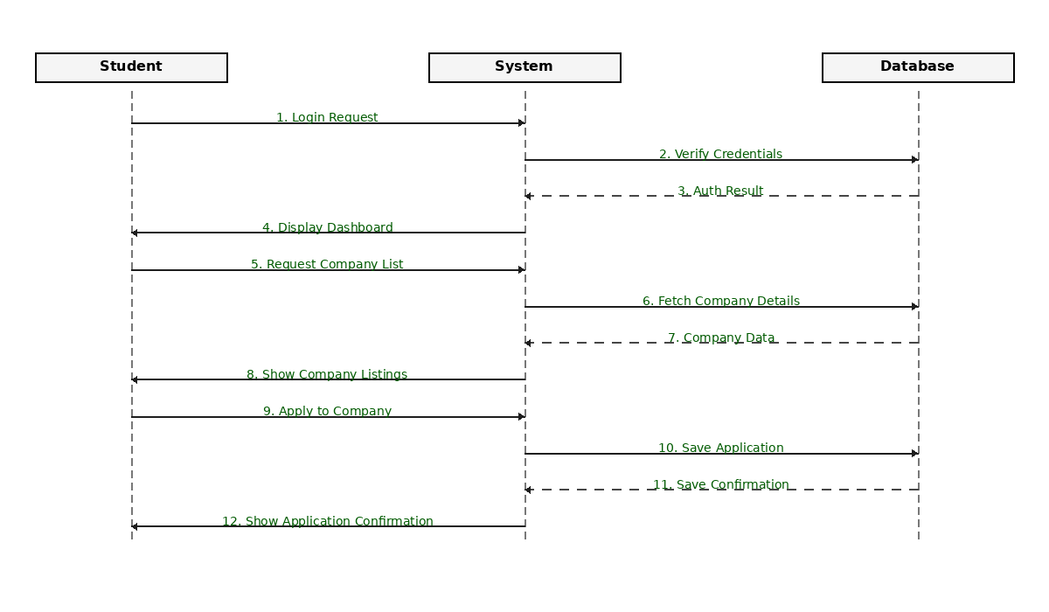

4.4.4 Flow Chart Diagram
A flowchart is a diagram that visually represents a process, workflow, or algorithm using standardized symbols and arrows. It shows the sequence of steps and decision points, making complex processes easier to understand, document, and improve. Flowcharts are used in various fields to plan, analyze, and communicate steps in a clear and logical way.
The following are the uses of a Flowchart:
- It is a pictorial representation of an algorithm that increases the readability of the program.
- Complex programs can be drawn in a simple way using a Flowchart.
- It helps team members get an insight into the process and use this knowledge to collect data, detect problems, develop software, etc.
- A Flowchart is a basic step for designing a new process or adding extra features.
- Communication with other people becomes easy by drawing Flowcharts and sharing them.

Flowcharts are mainly used in the below scenarios:

- It is most importantly used when programmers make projects. As a Flowchart is a basic step to make the design of projects pictorially, it is preferred by many.
- When the Flowcharts of a process are drawn, the programmer understands the non-useful parts of the process. So, Flowcharts are used to separate sound logic from the unwanted parts.
- Since the rules and procedures of drawing a Flowchart are universal, a Flowchart serves as a communication channel to the people who are working on the same project for better understanding.
- Optimizing a process becomes easier with Flowcharts. The efficiency of the code is improved with the Flowchart drawing.

Flowchart Diagram for placement Prediction System

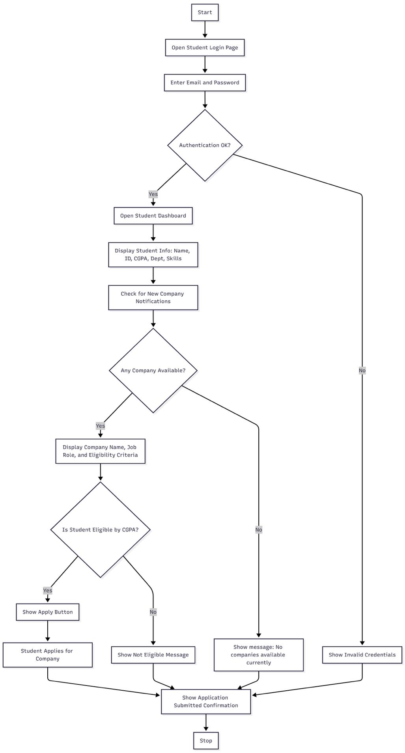

Seventh Page
In these pages the students must provide a table of contents, viz., List of tables, List of figures, List of symbols (Notations), Chapter wise contents, References etc. with starting Page Nos. of each item.
All the above pages (from Third page to seventh page) should be numbered only in Roman numerals, of lower case and the rest of the report should have English numeral numbers.
- Number of Pages
In case the number of pages in the thesis exceeds 100,
- Arrangements of Chapters
The following is suggested format for arranging the Thesis matter into various chapters. However this arrangement can be changed to suit the particular Research work.
  - Introduction
  - Literature Survey
  - Theoretical Analysis
  - Experimental Investigations
  - Experimental Results
  - Discussion of Results
  - Summary, Conclusion and Recommendations (Original Contribution to be highlighted)
  - Reference/bibliography
  - Appendices (if any)
- The Arrangement of paragraph in a Chapter
Each topic Title in a chapter should be properly numbered for example: 2.1, 2.2 etc., (Bold and Upper case) where, the first digit represents the Chapter number, and second digit, the topic Title number.
Sub-topic titles, if any, may be indicated as 1.1.1,1.1.2, etc.( Bold and title case) i.e .the representing the chapter, the second representing the topic title and the third representing the sub-topic title.
- Photographs and Tables:
The photographs and tables occurring in a chapter may be serially numbered as Fig: 1.1, 1.2 etc., along with suitable CAPTION where the first digit represents the chapter, the second digit represents figure number.
The photograph may be represented as: plate 1.1, 1.2 etc., the first representing chapter and the second representing the photograph number.
- Graphs:
The graph should clearly indicate the points which are used for drawing the curve or curves along with error bars. The axes ( X,Y and Z) should have CAPTIONS.
- Bibliography or References:
All references should be arranged in IEEE/ASME/ASCE format.

